1. Encode the bit stream above using the Differential Manchester line code. Assume that the last signal on the link had a positive polarity.

__H/L, L/H, L/H, L/H, H/L, H/L, L/H, L/H, H/L, L/H, H/L, L/H, L/H, L/H, L/H, L/H___

* In differential Manchester encoding, a transition between the two signal states - AT THE BEGINNING OF A BIT INTERVAL - represents bit ‘0’
* No transition AT THE BEGINNING OF A BIT INTERVAL - represents bit ‘1’

Correct: NTL, NTL, TL, TL, NTL, TL, NTL, TL, NTL, NTL, NTL, TNL, TL, TL, TL, TL

1. Draw the signal represented in question 5 above. Use the template below.

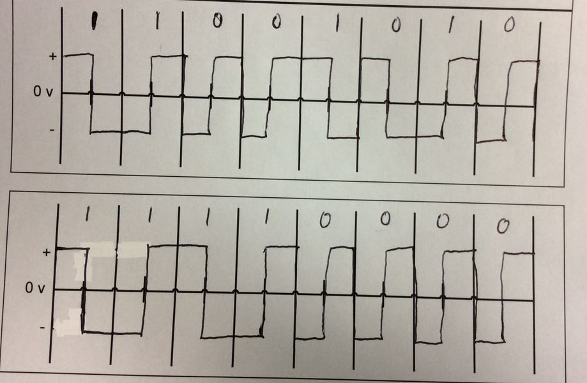

Figure 2: Signal created in question 5.

### Differential Manchester

### Transition at left edge of the bit interval determines the bit value. If the bit to be sent is a ‘0’ then there is a transition at the left edge. If the bit to be sent is a ‘1’ then there is no transition at the left edge. In both cases there is a transition in the middle of the bit interval.

|  |  |  |
| --- | --- | --- |
| **Bit** |  | **Transition at left edge** |
| 0 |  | TL |
| 1 |  | NTL (No transition left) |

*For the problems in this homework, assume that the last signal on the channel had positive polarity.*